**Sai Kankatala**

The first new angular project is created using a command “**ng new Assignment_3**”, and angular materials have been installed using “**ng add @angular/material**”.

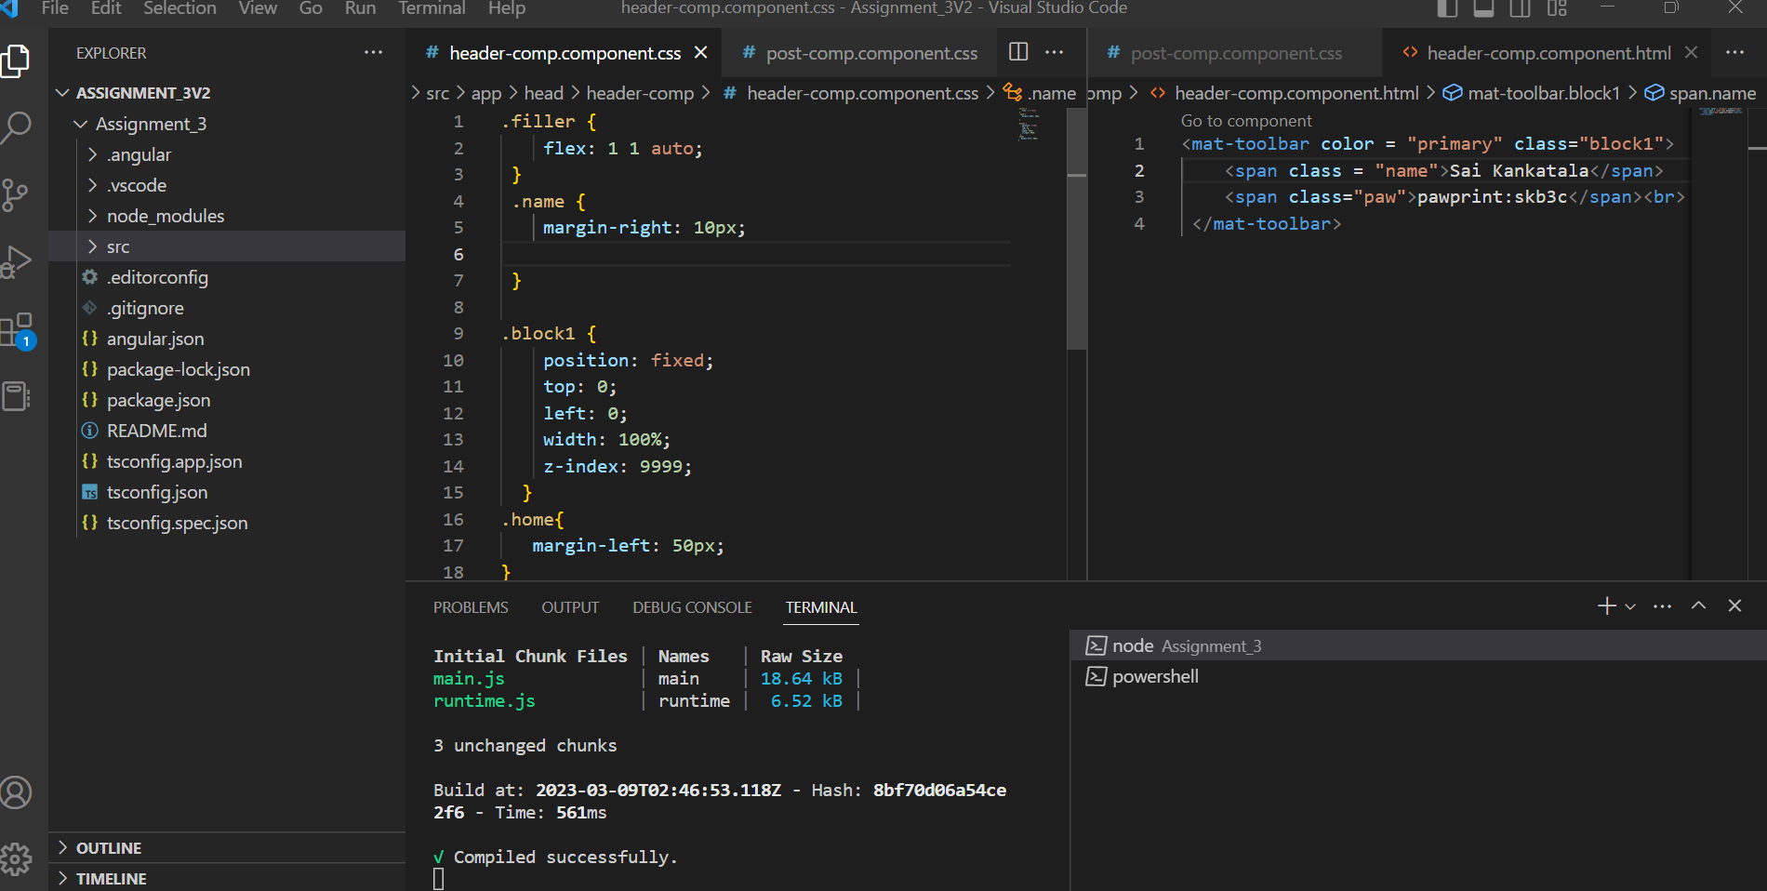

All the necessary imports have been imported correctly to “**app.module.ts**” to use the angular material.

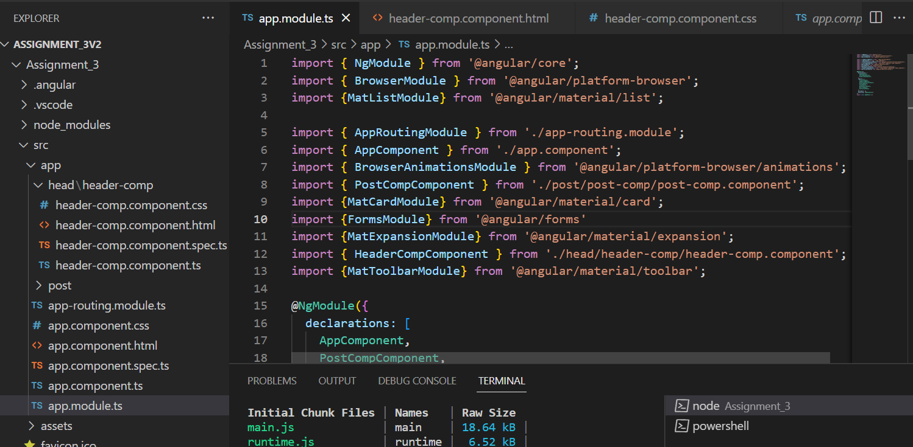

A new folder(post) has been created and new component(post-comp) is created. Inside the post-comp.component.html

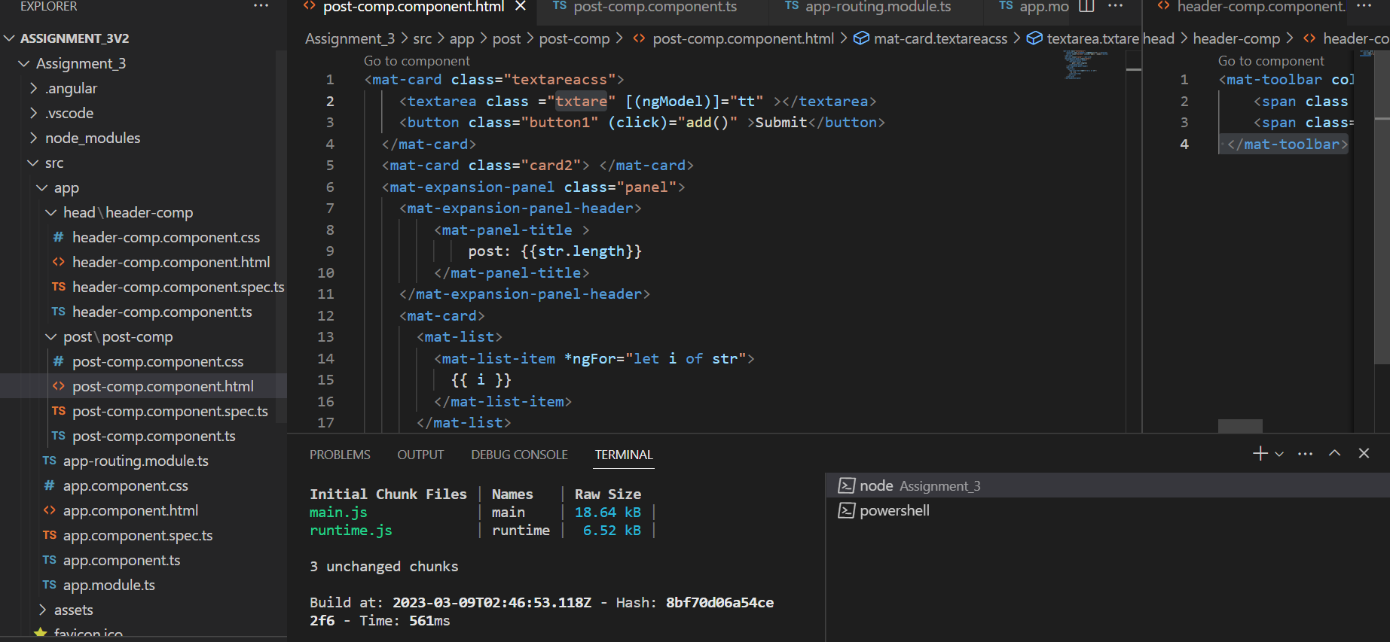

Two <mat-card> tags have been added as said in the assignment.

Inside the <mat-card> a text area is created and the two-way-binding is added to the text area.

A <mat-expansion-panel> is added to display the submitted text.

Now a text is typed in the text area and the submit button is clicked and output is shown on the right side of the screen.(For first post)

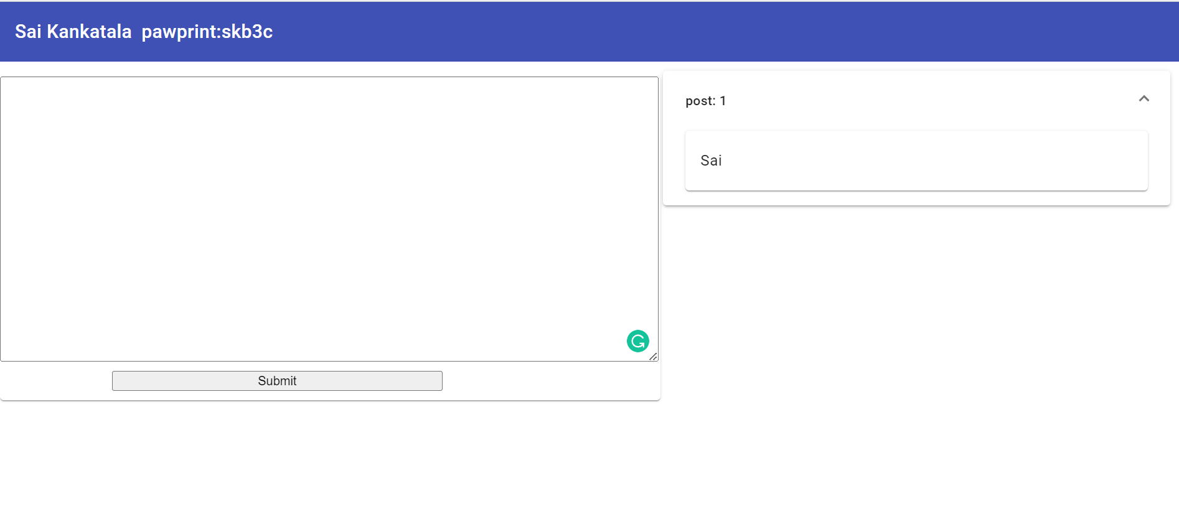

We also kept tracking of number of posts have been submitted and that also seen on the right side of the screen.(For post three)

All necessary CSS has been added in header-comp.component.css.

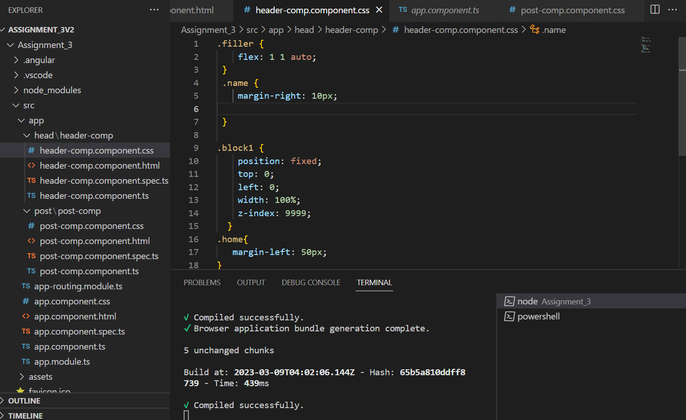

A new folder(head) have been created , inside that folder header-comp component is created.

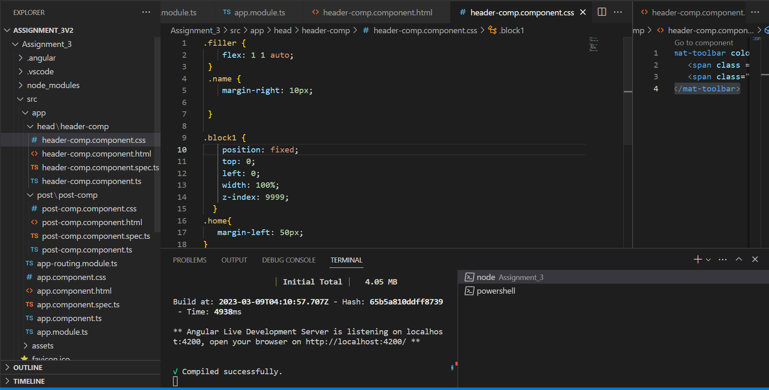

A toolbar is created using Angular material.

Header component is added to the app.component.html

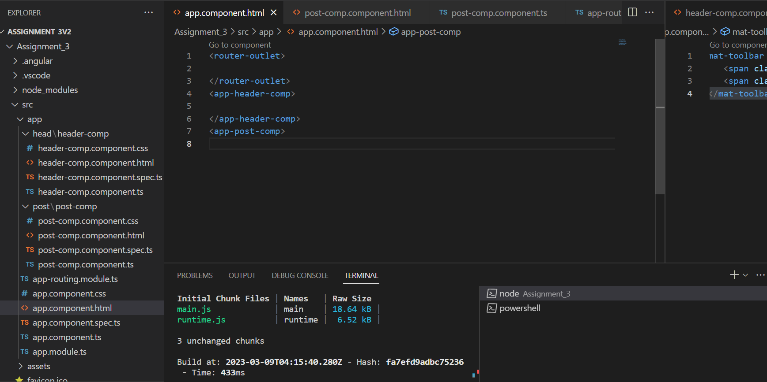

We can see in the header section the name and pawprint are displayed.

